МИНИСТЕРСТВО ОБРАЗОВАНИЯ И НАУКИ РОССИЙСКОЙ ФЕДЕРАЦИИ

**Федеральное государственное бюджетное образовательное учреждение высшего профессионального образования  
 «Кемеровский государственный университет»**

**Институт фундаментальных наук**

**Кафедра ЮНЕСКО по ИВТ**

**ЛАБОРАТОРНАЯ РАБОТА №8**

**ПО ДИСЦИПЛИНЕ “РАЗРАБОТКА МОБИЛЬНЫХ ПРИЛОЖЕНИЙ”**

студента 2 курса

**Крючкова Андрея Олеговича**

Направление 09.03.03 – Прикладная информатика в экономике

Преподаватель:

доцент

С.Ю. Завозкин

_____________________

Работа защищена:

“____”_______________202_г.

с оценкой _____________

Кемерово 202_

СОДЕРЖАНИЕ

1. Постановка задач 2

2. Реализация задач 3

Заключение 10

# 1. Постановка задач

1. Разработать приложение на библиотеке Retrofit, взаимодействующее со сторонним API
2. Реализовать приложение с RecycleView’ером, поддерживающим работу с различными ViewHolder’ами

# 2. Реализация задач

* 1. **Задание**

1)

<?xml version="1.0" encoding="utf-8"?>  
<LinearLayout xmlns:android="http://schemas.android.com/apk/res/android"  
 xmlns:app="http://schemas.android.com/apk/res-auto"  
 xmlns:tools="http://schemas.android.com/tools"  
 android:id="@+id/linearLayout"  
 android:layout_width="match_parent"  
 android:layout_height="match_parent"  
 android:orientation="vertical"  
 tools:context=".MainActivity">  
  
 <androidx.recyclerview.widget.RecyclerView  
 android:id="@+id/rView"  
 android:layout_width="match_parent"  
 android:layout_height="match_parent">  
  
 </androidx.recyclerview.widget.RecyclerView>  
  
</LinearLayout>

Код Activity_main.xml

2)

<?xml version="1.0" encoding="utf-8"?>  
<androidx.constraintlayout.widget.ConstraintLayout xmlns:android="http://schemas.android.com/apk/res/android"  
 xmlns:app="http://schemas.android.com/apk/res-auto"  
 xmlns:tools="http://schemas.android.com/tools"  
 android:id="@+id/linearLayout2"  
 android:layout_width="match_parent"  
 android:layout_height="100dp"  
 android:background="#FFFFFF">  
  
 <TextView  
 android:id="@+id/datetime_text"  
 android:layout_width="wrap_content"  
 android:layout_height="wrap_content"  
 android:text="TextView"  
 android:textColor="#000000"  
 app:layout_constraintBottom_toBottomOf="parent"  
 app:layout_constraintEnd_toEndOf="parent"  
 app:layout_constraintHorizontal_bias="0.045"  
 app:layout_constraintStart_toStartOf="parent"  
 app:layout_constraintTop_toTopOf="parent"  
 app:layout_constraintVertical_bias="0.197" />  
  
 <View  
 android:id="@+id/view1"  
 android:layout_width="wrap_content"  
 android:layout_height="1sp"  
 android:background="@android:color/black"  
 app:layout_constraintBottom_toBottomOf="parent"  
 app:layout_constraintEnd_toEndOf="parent"  
 app:layout_constraintHorizontal_bias="0.0"  
 app:layout_constraintStart_toStartOf="parent"  
 app:layout_constraintTop_toTopOf="parent"  
 app:layout_constraintVertical_bias="1.0" />  
  
 <LinearLayout  
 android:layout_width="wrap_content"  
 android:layout_height="wrap_content"  
 android:layout_marginTop="4dp"  
 app:layout_constraintEnd_toEndOf="parent"  
 app:layout_constraintTop_toTopOf="parent">  
  
 <ImageView  
 android:id="@+id/imageView2"  
 android:layout_width="wrap_content"  
 android:layout_height="wrap_content"  
 android:layout_marginEnd="15dp"  
 app:layout_constraintBottom_toBottomOf="parent"  
 app:layout_constraintEnd_toStartOf="@+id/temperature_text"  
 app:layout_constraintTop_toTopOf="parent"  
 app:srcCompat="@drawable/fire" />  
  
 <TextView  
 android:id="@+id/temperature_text"  
 android:layout_width="70dp"  
 android:layout_height="wrap_content"  
 android:layout_marginEnd="20dp"  
 android:text="TextView"  
 android:textColor="#000000"  
 android:textSize="20sp"  
 app:layout_constraintBottom_toBottomOf="parent"  
 app:layout_constraintEnd_toEndOf="parent"  
 app:layout_constraintTop_toTopOf="parent" />  
 </LinearLayout>  
  
</androidx.constraintlayout.widget.ConstraintLayout>

Код rview_item.xml

<?xml version="1.0" encoding="utf-8"?>  
<androidx.constraintlayout.widget.ConstraintLayout xmlns:android="http://schemas.android.com/apk/res/android"  
 xmlns:app="http://schemas.android.com/apk/res-auto"  
 xmlns:tools="http://schemas.android.com/tools"  
 android:id="@+id/linearLayout2"  
 android:layout_width="match_parent"  
 android:layout_height="100dp"  
 android:background="#FFFFFF">  
  
 <TextView  
 android:id="@+id/temperature_text"  
 android:layout_width="70dp"  
 android:layout_height="wrap_content"  
 android:layout_marginEnd="15dp"  
 android:text="TextView"  
 android:textColor="#000000"  
 android:textSize="20sp"  
 app:layout_constraintBottom_toBottomOf="parent"  
 app:layout_constraintEnd_toStartOf="@+id/imageView"  
 app:layout_constraintTop_toTopOf="parent" />  
  
 <TextView  
 android:id="@+id/datetime_text"  
 android:layout_width="wrap_content"  
 android:layout_height="wrap_content"  
 android:text="TextView"  
 android:textColor="#000000"  
 app:layout_constraintBottom_toBottomOf="parent"  
 app:layout_constraintEnd_toEndOf="parent"  
 app:layout_constraintHorizontal_bias="0.045"  
 app:layout_constraintStart_toStartOf="parent"  
 app:layout_constraintTop_toTopOf="parent"  
 app:layout_constraintVertical_bias="0.197" />  
  
 <View  
 android:id="@+id/view1"  
 android:layout_width="wrap_content"  
 android:layout_height="1sp"  
 android:background="@android:color/black"  
 app:layout_constraintBottom_toBottomOf="parent"  
 app:layout_constraintEnd_toEndOf="parent"  
 app:layout_constraintHorizontal_bias="0.0"  
 app:layout_constraintStart_toStartOf="parent"  
 app:layout_constraintTop_toTopOf="parent"  
 app:layout_constraintVertical_bias="1.0" />  
  
 <ImageView  
 android:id="@+id/imageView"  
 android:layout_width="55dp"  
 android:layout_height="50dp"  
 android:layout_marginEnd="20dp"  
 app:layout_constraintBottom_toBottomOf="parent"  
 app:layout_constraintEnd_toEndOf="parent"  
 app:layout_constraintTop_toTopOf="parent"  
 app:srcCompat="@drawable/ic_launcher" />  
  
</androidx.constraintlayout.widget.ConstraintLayout>

rview_item2.xml

4)

package com.example.retrofitforecaster  
  
  
import android.graphics.Color  
import android.view.LayoutInflater  
import android.view.View  
import android.view.ViewGroup  
import android.widget.TextView  
import androidx.recyclerview.widget.DiffUtil  
import androidx.recyclerview.widget.ListAdapter  
import androidx.recyclerview.widget.RecyclerView  
  
class ContactItemDiffCallback : DiffUtil.ItemCallback<ListItem>(){  
 override fun areItemsTheSame(oldItem: ListItem, newItem: ListItem) = oldItem == newItem  
  
 override fun areContentsTheSame(oldItem: ListItem, newItem: ListItem) = oldItem == newItem  
  
}  
  
class ViewHolderCold(view: View) : RecyclerView.ViewHolder(view) {  
 val datetime: TextView = view.findViewById(R.id.*datetime_text*)  
 val temperature: TextView = view.findViewById(R.id.*temperature_text*)  
  
 fun bindTo(weather: ListItem, position: Int){  
 if (temperature != null) {temperature.*text* = weather.main.temp.toString()}  
 if (datetime != null) {datetime.*text* = weather.dt_txt}  
  
 }  
}  
  
class ViewHolderHot(view: View) : RecyclerView.ViewHolder(view) {  
 val datetime: TextView = view.findViewById(R.id.*datetime_text*)  
 val temperature: TextView = view.findViewById(R.id.*temperature_text*)  
  
  
  
 fun bindTo(weather: ListItem){  
 if (temperature != null) {temperature.*text* = weather.main.temp.toString()}  
 if (datetime != null) {datetime.*text* = weather.dt_txt}  
  
 }  
}  
  
class Adapter : ListAdapter<ListItem, RecyclerView.ViewHolder>(ContactItemDiffCallback()){  
  
 override fun onCreateViewHolder(parent: ViewGroup, viewType: Int): RecyclerView.ViewHolder {  
 if(viewType == 0){ val view = LayoutInflater.from(parent.*context*).inflate(R.layout.*rview_item*, parent, false)  
 view.setBackgroundColor(Color.rgb(208, 65, 65))  
 return ViewHolderHot(view)}  
 else{  
 val view = LayoutInflater.from(parent.*context*).inflate(R.layout.*rview_item2*, parent, false)  
 view.setBackgroundColor(Color.rgb(26, 103, 212))  
 return ViewHolderCold(view)  
 }  
 }  
 override fun onBindViewHolder(holder: RecyclerView.ViewHolder, position: Int) {  
 val data = *currentList*[position]  
 if(data.main.temp>0) {  
 val viewholderhot: ViewHolderHot = holder as ViewHolderHot  
 viewholderhot.bindTo(data)  
 }else{  
 val viewholdercold: ViewHolderCold = holder as ViewHolderCold  
 viewholdercold.bindTo(data,position)  
 }  
 }  
 override fun getItemViewType(position: Int): Int {  
 return if (*currentList*[position].main.temp>0) {  
 0  
 } else {  
 1  
 }  
 }  
}

Adaper.kt

5)

package com.example.retrofitforecaster  
  
import com.example.retrofitforecaster.RetrofitServices  
import com.example.retrofitforecaster.RetrofitClient  
  
object Common {  
 private val BASE_URL = "https://api.openweathermap.org/data/2.5/"  
 val retrofitService: RetrofitServices  
 get() = RetrofitClient.getClient(BASE_URL).create(RetrofitServices::class.*java*)  
}

Common.kt

6)

package com.example.retrofitforecaster  
  
import retrofit2.Retrofit  
import retrofit2.converter.gson.GsonConverterFactory  
  
object RetrofitClient {  
 private var retrofit: Retrofit? = null  
  
 fun getClient(baseUrl: String): Retrofit {  
 if (retrofit == null) {  
 retrofit = Retrofit.Builder()  
 .baseUrl(baseUrl)  
 .addConverterFactory(GsonConverterFactory.create())  
 .build()  
 }  
 return retrofit!!  
 }  
}

RetrofitClient.kt

7)

package com.example.retrofitforecaster  
  
import android.content.Context  
import android.content.SharedPreferences  
import androidx.appcompat.app.AppCompatActivity  
import android.os.Bundle  
import android.util.Log  
import android.view.inputmethod.InputMethodManager  
import android.widget.Button  
import android.widget.EditText  
import androidx.recyclerview.widget.LinearLayoutManager  
import androidx.recyclerview.widget.RecyclerView  
import retrofit2.Call  
import retrofit2.Callback  
import retrofit2.Response  
import androidx.recyclerview.widget.ListAdapter  
import timber.log.Timber  
import java.io.IOException  
import java.security.spec.ECField  
  
  
class MainActivity : AppCompatActivity() {  
  
 lateinit var mService: RetrofitServices  
 lateinit var layoutManager: LinearLayoutManager  
 val adapter = Adapter()  
 var listweather = *listOf*<ListItem>()  
 override fun onCreate(savedInstanceState: Bundle?) {  
 super.onCreate(savedInstanceState)  
 setContentView(R.layout.*activity_main*)  
 Timber.plant(Timber.DebugTree())  
 val recyclerView: RecyclerView = findViewById(R.id.*rView*)  
 *title* = ""  
 mService = Common.retrofitService  
 layoutManager = LinearLayoutManager(this)  
 recyclerView.*layoutManager* = layoutManager  
 recyclerView.*adapter* = adapter  
  
 getAllWeatherList("shklov")  
  
 }  
  
 fun getAllWeatherList(city: String) {  
 mService.getWeatherList(city).enqueue(object : Callback<DataWeather> {  
 override fun onResponse(call: Call<DataWeather>, response: Response<DataWeather>) {  
 try {  
 val abc = response.body() as DataWeather  
 listweather = abc.list  
 Log.d("123", abc.cod)  
 adapter.submitList(listweather)  
 adapter.notifyDataSetChanged()  
 }catch(e: IOException){  
 Timber.e("Город не найден")  
 }  
 }  
 override fun onFailure(call: Call<DataWeather>, t: Throwable) {  
 Log.d("123", t.message.*toString*())  
 }  
 })  
 }  
  
}

MainActivity.kt

8)

package com.example.retrofitforecaster  
  
import retrofit2.Call  
import retrofit2.http.*  
  
interface RetrofitServices {  
 @GET("forecast?&appid=625b6fd5c5be3e9c809460446a1fd3e9&units=metric&lang=ru")  
 fun getWeatherList(@Query("q")name: String): Call<DataWeather>  
}

RetrofitServices,kt

9)

package com.example.retrofitforecaster  
  
data class DataWeather(val cod: String = "",  
 val message: Int = 0,  
 val cnt: Int = 0,  
 val list: List<ListItem>,  
 val city: City)  
  
data class ListItem(val dt: String = "",  
 val main: Main,  
 val weather: List<WeatherItem>?,  
 val clouds: Clouds,  
 val wind: Wind,  
 val visibility: String = "",  
 val pop: String = "",  
 val sys: Sys,  
 val dt_txt: String = "")  
  
data class City(val country: String = "",  
 val coord: Coord,  
 val sunrise: Int = 0,  
 val timezone: Int = 0,  
 val sunset: Int = 0,  
 val name: String = "",  
 val id: Int = 0,  
 val population: Int = 0)  
  
data class Main(val temp: Double = 0.0,  
 val tempMin: Double = 0.0,  
 val grndLevel: Int = 0,  
 val tempKf: Double = 0.0,  
 val humidity: Int = 0,  
 val pressure: Int = 0,  
 val seaLevel: Int = 0,  
 val feelsLike: Double = 0.0,  
 val tempMax: Double = 0.0)  
  
data class WeatherItem(val icon: String = "",  
 val description: String = "",  
 val main: String = "",  
 val id: Int = 0)  
  
data class Coord(val lon: Double = 0.0,  
 val lat: Double = 0.0)  
  
data class Clouds(val all: Int = 0)  
  
data class Sys(val pod: String = "")  
  
data class Wind(val deg: Int = 0,  
 val speed: Double = 0.0,  
 val gust: Double = 0.0)

Data.kt

Итоговое приложение

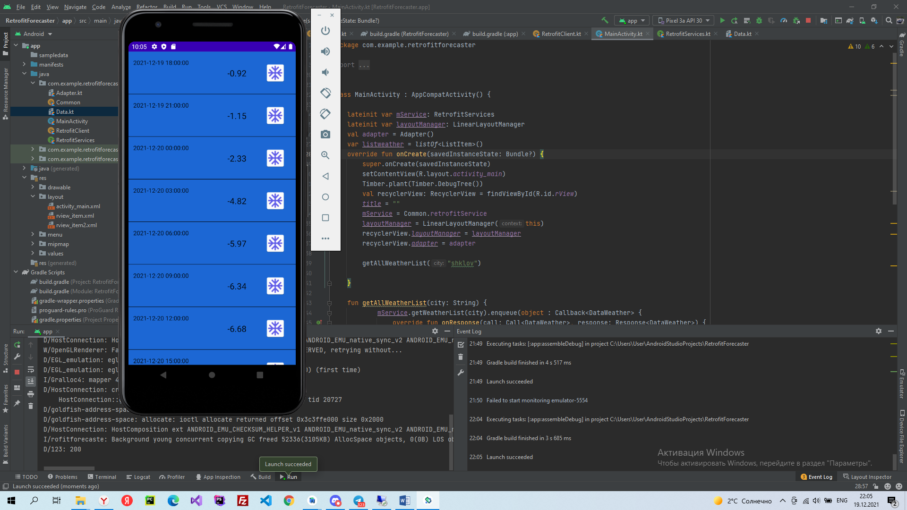

# Заключение

Я ознакомился с возможностями библиотеки RetroFit, а также научиться использовать в одном объекте RecyclerView разные типы ViewHolder’ов.

**Литература**

1. OpenWeatherMap - <https://openweathermap.org/>
2. Retrofit - <https://square.github.io/retrofit/>
3. 5 day weather forecast - <https://openweathermap.org/forecast5>
4. Retrofit2 на Android - <https://habr.com/ru/post/520544/>
5. Android and Kotlin: RecyclerView with multiple view types - <https://medium.com/@ivancse.58/android-and-kotlin-recyclerview-with-multiple-view-types-65285a254393>
6. Android RecyclerView with multiple view type (multiple view holder) - <https://droidbyme.medium.com/android-recyclerview-with-multiple-view-type-multiple-view-holder-af798458763b>